Multi-Class Skin Disease Classification Using Deep Learning

Project Overview
This project develops an AI-powered skin disease classification system using the HAM10000 dataset. Multiple CNN and transfer learning models were trained to classify seven types of skin lesions. After evaluation and optimization, ResNet50 was selected as the final model. The trained model was deployed as a Flask web application with image diagnosis, Grad-CAM visualization, model analytics, and report generation features.

Dataset Overview
The project uses the Skin Cancer MNIST: HAM10000 dataset, which contains dermatoscopic images of seven different skin disease classes. The dataset is used to train, validate, and evaluate deep learning models for accurate multi-class skin disease classification.

Data Understanding
The HAM10000 dataset was analyzed to understand its structure and class distribution before model development. The dataset consists of dermatoscopic images belonging to seven skin disease categories. Image dimensions, quality, and class distribution were examined, and the dataset was divided into training, validation, and testing sets to support effective model training and evaluation.

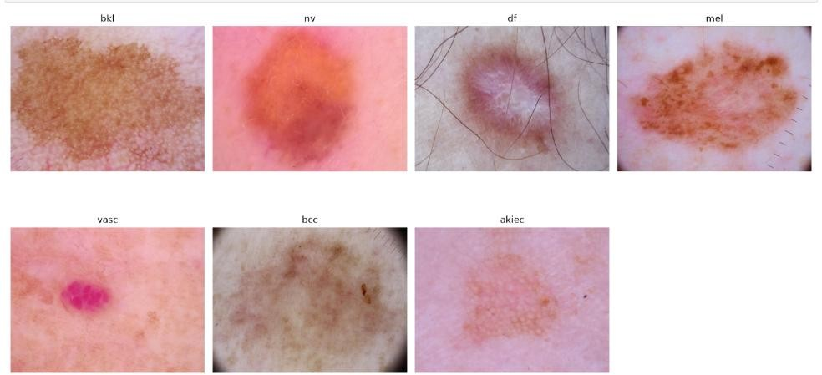

Figure 1: Sample images

Data Preprocessing
The dataset was preprocessed to prepare the images for deep learning model training. Images were resized to 224 × 224 pixels, pixel values were normalized, data augmentation techniques were applied to increase data diversity, class imbalance was handled using class weights, and TensorFlow data pipelines were created for efficient training, validation, and testing.

Dataset Split Summary

Dataset | Shape | Percentage
Training | (7010, 8) | 70%
Validation | (1502, 8) | 15%
Testing | (1503, 8) | 15%

Exploratory Data Analysis (EDA)
Exploratory Data Analysis (EDA) was performed to understand the characteristics of the HAM10000 dataset before model development. The analysis focused on image distribution, pixel intensity patterns, and visual characteristics of each skin disease class. This helped identify dataset patterns and supported the development of effective deep learning models.

Model Development
Multiple deep learning models were developed and trained to classify seven skin disease classes using the preprocessed HAM10000 dataset. Both custom CNN architectures and transfer learning models were evaluated under the same training configuration to ensure a fair performance comparison.

Models Developed
- Basic CNN
- Deep CNN
- CNN + Batch Normalization
- CNN + Dropout
- MobileNetV2
- EfficientNetB0
- ResNet50
- DenseNet121

Model | Train  Accura ncy | Validation Accurancy | Test  Accuranc y | Train Loss | Validation Loss | Test loss
Basic CNN | 49.93 | 49.93 | 49.93 | 49.93 | 49.93 | 49.93
Deep CNN | 47.97 | 47.97 | 47.97 | 47.97 | 47.97 | 47.97
Batch Normaliz  ation | 47.55 | 47.55 | 47.55 | 47.55 | 47.55 | 47.55
CNN  DropOut | 53.24 | 53.24 | 53.24 | 53.24 | 53.24 | 53.24
MobileN etV2 | 60.31 | 60.31 | 60.31 | 60.31 | 60.31 | 60.31
Efficient NetB0 | 55.93 | 55.93 | 55.93 | 55.93 | 55.93 | 55.93
ResNet50 | 59.43 | 59.43 | 59.43 | 59.43 | 59.43 | 59.43
DenseNet 121 | 53.41 | 53.41 | 53.41 | 53.41 | 53.41 | 53.41

Observation: Among all the trained models, MobileNetV2 achieved the highest training, validation, and test accuracy, making it the best-performing baseline model

Model Improvement
To improve the performance of the baseline models, several optimization techniques were applied during training. These techniques enhanced model convergence, reduced overfitting, and improved classification accuracy. Different optimizers were also evaluated, and ResNet50 with the SGD optimizer achieved the best overall performance.

Optimization Techniques
- Data Augmentation
- Batch Normalization
- Dropout
- Early Stopping
- Learning Rate Scheduling
- Optimizer Comparison (SGD, Adam, RMSprop)
- Fine-Tuning of Transfer Learning Models

Result
The performance of the models improved after applying the optimization techniques. Among the transfer learning models, ResNet50 trained with the SGD optimizer achieved the highest accuracy and overall performance. Therefore, the optimized ResNet50 (SGD) model was selected as the final model for evaluation, Explainable AI analysis, and deployment in the Flask web application.

Model Evaluation & Comparison
The optimized deep learning models were evaluated using standard classification metrics to measure their prediction performance and generalization ability. A comparative analysis was performed to identify the most accurate and reliable model for skin disease classification.

Evaluation Metrics
- Accuracy
- Precision
- Recall
- F1-Score
- ROC-AUC
- Confusion Matrix

Summary
Based on the evaluation results, ResNet50 trained with the SGD optimizer achieved the best overall performance and was selected as the final model for Explainable AI analysis and deployment in the Flask web application.

Explainable AI
Explainable Artificial Intelligence (XAI) was used to improve the transparency of the final deep learning model. Grad-CAM (Gradient-weighted Class Activation Mapping) was applied to visualize the image regions that contributed most to the prediction made by the ResNet50 (SGD) model. These visual explanations help verify that the model focuses on the relevant lesion area during classification.

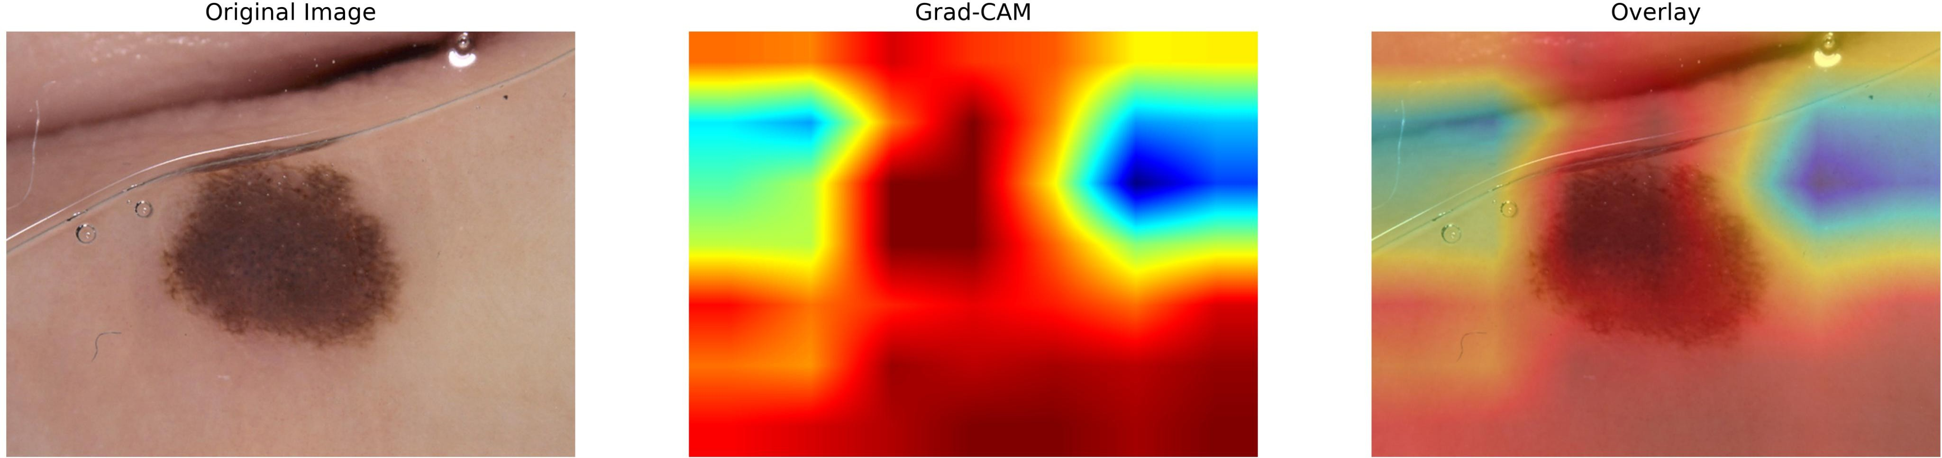

Figure 2: Combined Together

Outcome

The Grad-CAM visualizations confirmed that the ResNet50 (SGD) model accurately focused on the lesion regions, providing interpretable and reliable predictions for skin disease classification.

Flask Web Application
A Flask-based web application was developed to provide an interactive interface for skin disease classification. The application integrates the trained ResNet50 (SGD) model and enables users to upload skin lesion images, obtain predictions, visualize Grad-CAM results, compare model performance, and generate downloadable reports.

Application Modules
- Dashboard
- Image Diagnosis
- Explain Prediction (Grad-CAM)
- Model Analytics
- Reports

Technologies Used
- Python
- Flask
- TensorFlow / Keras
- OpenCV
- Bootstrap 5
- HTML5, CSS3, JavaScript

Screenshots

Dashboard

Prediction

Explain Prediction (Grad-CAM)

Model Analytics

Reports

Conclusion
A complete deep learning solution was developed for multi-class skin disease classification using the HAM10000 dataset. Multiple CNN and transfer learning models were trained, optimized, and evaluated to identify the best-performing model. After applying optimization techniques, ResNet50 with the SGD optimizer achieved the highest overall performance and was selected as the final model. The model was successfully deployed through a Flask web application, providing image diagnosis, Grad-CAM visualization, model analytics, and report generation in an interactive and user-friendly environment.

